

**Development Test**

Prepared by: **BE-terna d.o.o.**

Vladimira Popovića 38-40, 11000 Belgrade

www.adacta.rs

Version: 1.0

Date: Beograd, 07.12.2020.

Contents

Customer Log Entry 3

A. Create Customer Log Entry table with following fields: 3

B. Create Page Customer Log Entries that will show following fields: 3

C. Create new Action on page Customer List, Customer Card 3

D. Customer Log Manangement 4

E. Execution of procedure InsertCustomerLogEntry (connect on Page Triggers using Event Subscriber) 5

F. Customer Table Customization 6

G. Report 7

Support links 10

# Customer Log Entry

## Create Customer Log Entry table with following fields:

|  |  |  |
| --- | --- | --- |
| **Field Name** | **Field Type** | **Value** |
| Entry No. | Integer |  |
| Customer No. | Code20 |  |
| Customer Name | Text100 - FlowField | Relation to Customer field Name, reference Customer No. = No. |
| Description | Text100 |  |
| Source Page | Integer |  |
| Operation Type | Enum | “ ”,Insert,Modify,Delete |
| Time of Modification | Time |  |
| Date of Modification | Date |  |
| User ID | Code[50] | User.”User Name” |
| Salespers./Purch. Code | Code20 - FlowField | Relation to User Setup field Salespers./Purch. Code, reference “User ID” = “User ID” |

Set all standard properties (Caption, DataClassification, etc)

## Create Page Customer Log Entries that will show following fields:

Customer Name, Source Page, Operation Type, Date of Modification, Time of Modification, User ID, Salespers./Purch. Code

Page Type: List

Property: Insert = No, Delete = No

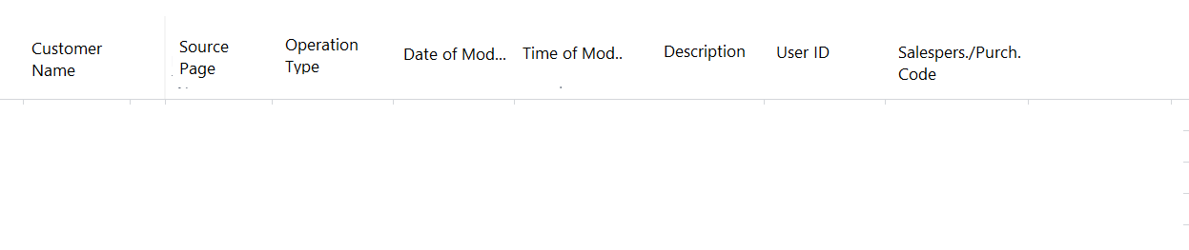

User can only manually change Description column. All other fields will be non-editable.

## Create new Action on page Customer List, Customer Card

Use Page Extension

Action will open Customer Log Entries Page filtered with Customer No.:

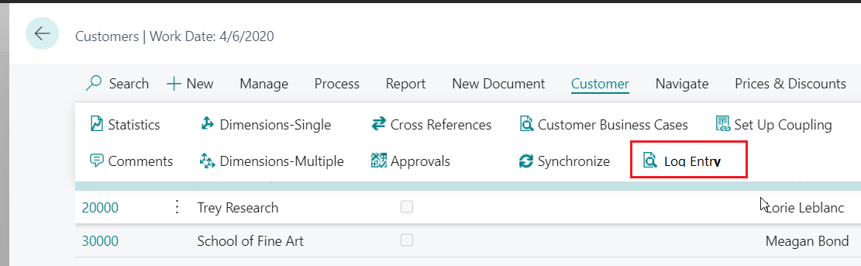

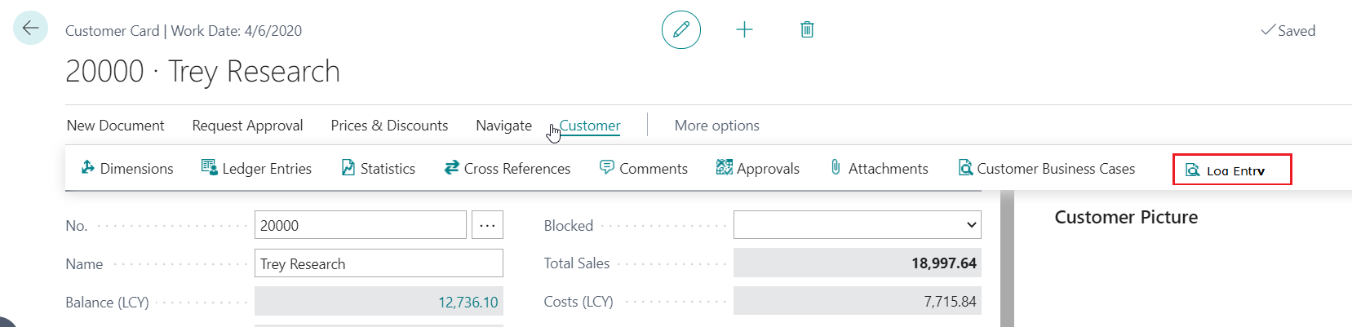

Action will set filter on Customer No. field and open page Customer Log Entries:

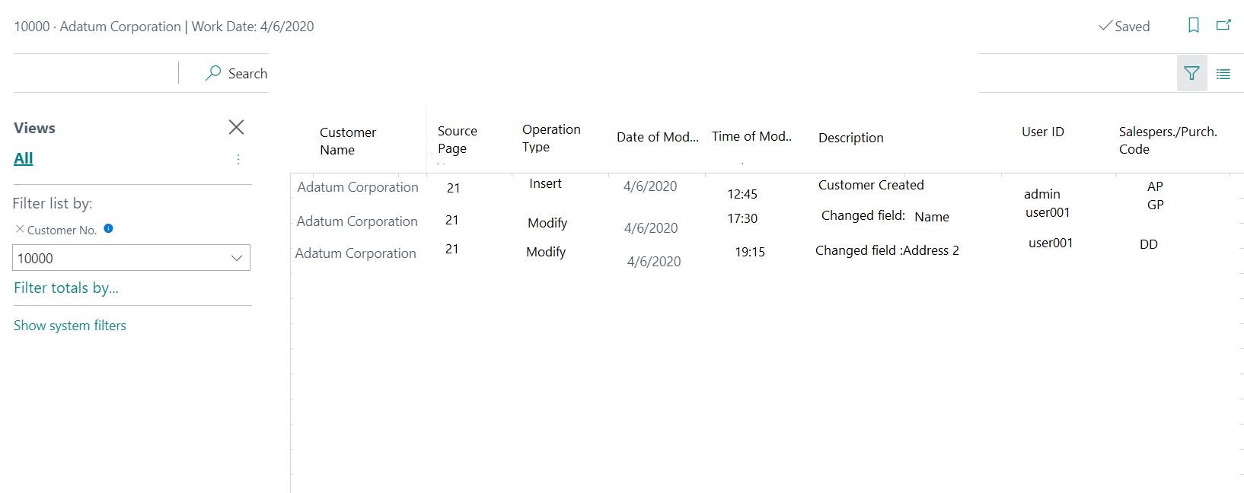

## Customer Log Manangement

Create Codeunit “Customer Log Manangement”

* Create global procedure “InsertCustomerLogEntry” that will receive following parameters:  
  Customer No., Description, Source Page, Operation type

This procedure will create new entry in table Customer Log Entry using parameters.

During entry creation fields date, time and user will be updated automatically (with system data: current date, time and UserID).

Entry No. will also be automatically calculated so that every new entry has new incremented ID: Last Entry No. + 1 (you need to create procedure that will get last entry No. in Customer Log Entry table and then you need to increment it by 1):

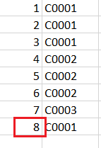 8 + 1, new Entry No. will be 9

Example of entries created by this procedure:

1, 11000, CoST Corporation, Customer Created, 21, Insert,11:15,22/09/2020, ADMIN, AB

2, 13000, PPOP Corporation, Customer Created, 21, Insert,11:52,22/09/2020, ADMIN, AB

3, 13000, PPOP Corporation, Changed Field: Address, 21, Modify,11:52,22/09/2020, ADMIN, AB

* Create global procedure DeleteCustomerLogEntry:  
  This procedure will receive Customer No. as parameter, and it will find and delete all Customer Log Entries connected with that Customer No.

**When customer is deleted from table, using procedure DeleteCustomerLogEntry you will delete all Log Entry for deleted customer. (use event subscriber on table trigger)**

* Create global procedure FindLastLogInserted

This procedure will receive Customer No. as parameter and search table Customer Log Entry, with filter Operation Type = Insert and Customer No. from parameter. System will return Date and time of last inserted log entry for that Customer, return value will be text.

Result will return concatenated values Date and Times as one text (DD/MM/YYY – HH:MM) (use Format function for that)

Create Action on Customer Card that will show result as message:

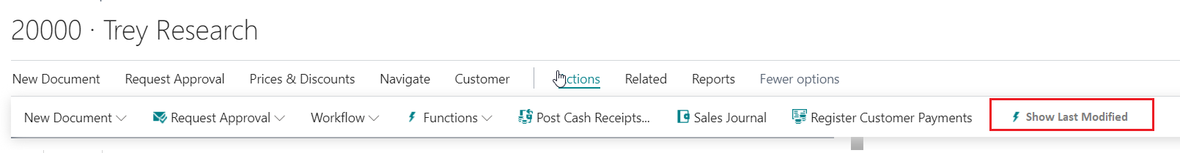

When user click on action, system will call function FindLastLogInserted, and returned value system will put in message, that will be presented to the user:

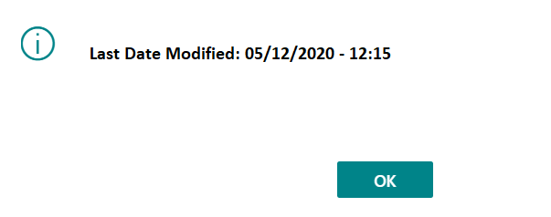

## Execution of procedure InsertCustomerLogEntry (connect on Page Triggers using Event Subscriber)

* When user create new Customer from Customer Card page ID 21, system will call function InsertCustomerLogEntry(CustomerNo,Customer Created,Page::”Customer Card”,OperationType::Insert)

Result:  
Table Customer Log Entry:

1, 1000, CoST Corporation, Customer Created, 21, Insert,11:10,22/09/2020, ADMIN, AB

* When user modify Customer Address from Customer Card page ID 21, system will call function InsertCustomerLogEntry(CustomerNo,ChangeFieldTxt,Page::”Customer Card”,OperationType::Modify)

Result:  
Table Customer Log Entry:

2, 1000, CoST Corporation, Changed Field: Address, 21, Modify,11:10,22/09/2020, ADMIN, AB

* When user fill in Customer Name or Customer No. on Sales Order, system will call function InsertCustomerLogEntry(CustomerNo,InsertTxt,Page::”Sales Order”,OperationType::Insert)

InsertTxt := ‘Customer No. 10000 is entered on Document No. 11005’

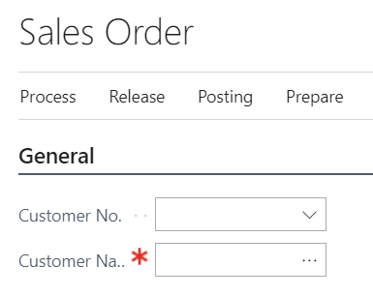

Result:  
Table Customer Log Entry:

3, 1000, CoST Corporation, Customer No. 1000 is entered on Document No. 11005, 42, Insert,11:10,22/09/2020, ADMIN, AB

…

* When user change current Customer Name or Customer No. on Sales Order, to different Customer No., system will call function twice (example, change from Customer No. 1000 to 3000) InsertCustomerLogEntry(OldCustomerNo,DeleteTxt,Page::”Sales Order”,OperationType::Delete)

DeleteTxt := ‘Customer No. 1000 is removed from Document No. 11005’

InsertCustomerLogEntry(OldCustomerNo, InsertTxt,Page::”Sales Order”,OperationType::Inseret)

InsertTxt:= ‘Customer No. 3000 is entered on Document No. 11005’

Result:  
Table Customer Log Entry:

25, 1000, CoST Corporation, Customer No. 1000 is removed from Document No. 11005, 42, Delete,11:15,22/09/2020, ADMIN, AB

26, 3000, PPOP Corporation, Customer No. 3000 is entered on Document No. 11005, 42, Insert,11:15,22/09/2020, ADMIN, AB

Same logic should be applied on Sales Quote, Sales Invoice, Sales Credit Memo

## Customer Table Customization

On Customer table create new field:  
No. of Log Entries – Type: FlowField, CalcFormula: Relation on Customer Log Entry based on reference Customer No. = No. field on Customer table (function Count)

Show this field on Customer Card ID:

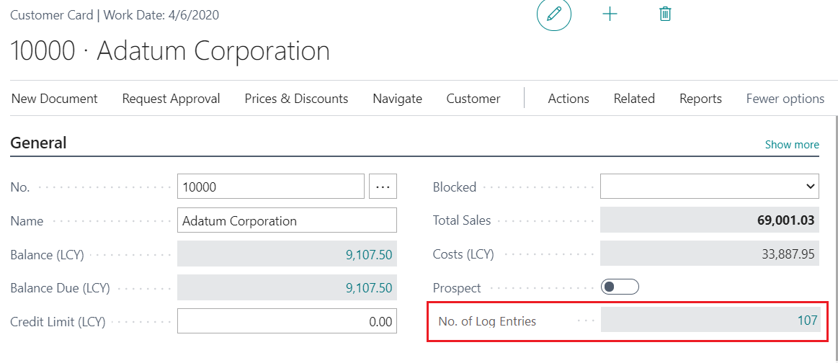

When user click on number, page Customer Log Entries page should be open showing Customer Log Entries data with filtered by Customer No.

When user hide General tab, field should be promoted and presented like this:  


## Report

Create RDL report that will look like this:

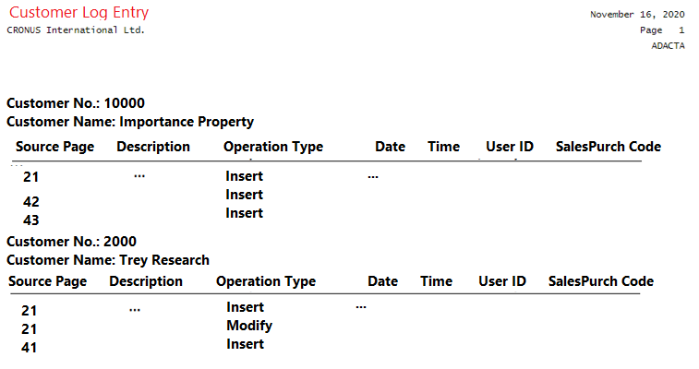

Report will have two data items:  
Customer (Parent DataItem)  
 Customer Log Entry (Child DataItem) – relation Customer No. = Customer.”No.”

For guideline how to develop report, use standard report ID 108:  
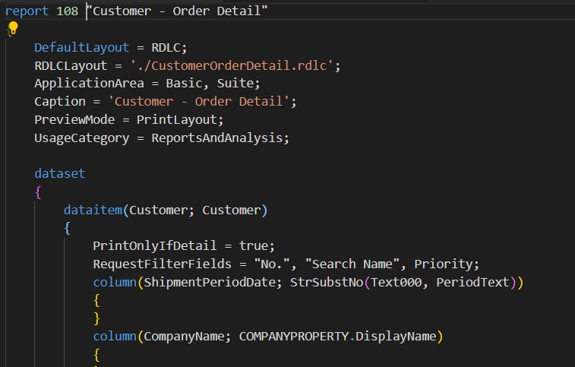

Report will be run from Customer Card and Customer List page using action:  
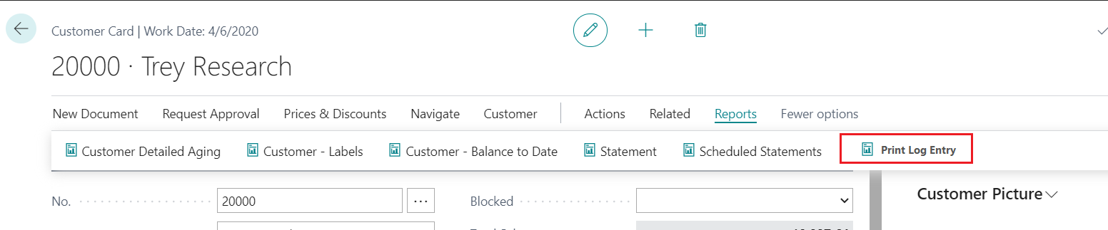

When report is run using Action, request page will open and Customer No. will be set:  
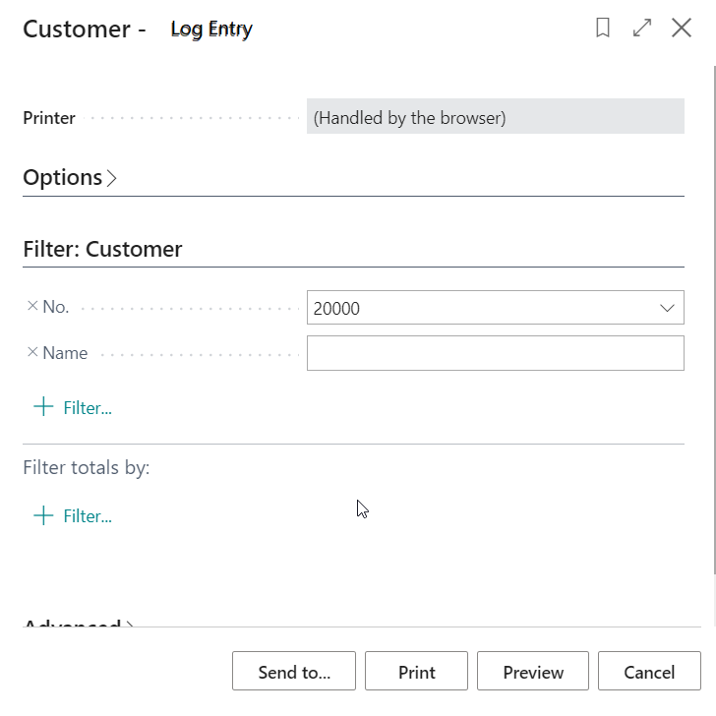

# Support links

[How to Write Subscription Events in AL Language | Dynamics 365 Business Central - YouTube](https://www.youtube.com/watch?v=fv4wxNoulIA)

Flow Fields:

<https://youtu.be/xXS3txLkm7k?t=226>

[Subscribing to Events - Business Central | Microsoft Docs](https://docs.microsoft.com/en-us/dynamics365/business-central/dev-itpro/developer/devenv-subscribing-to-events)

[How do I add AL code to an extension? | Dynamics 365 Business Central Apps - YouTube](https://www.youtube.com/watch?v=R9o2t3whmB4)

Importance Property:

<https://docs.microsoft.com/en-us/dynamics365/business-central/dev-itpro/developer/properties/devenv-importance-property>

Report design:

<https://www.youtube.com/watch?v=43dRNaIpfYw>